HUNTER TRIALS – ADDITIONAL RULES FOR PAIRS
- All fences are marked for jumping errors excluding those in the time section which must all still be jumped in the right order but will not be faulted other than time faults.
- Any competitor in classes 3 who has three refusals at one fence may continue but may not have more than three attempts at any jump. This permission may be withdrawn if the ground conditions are such that damage is being caused or it is deemed unsafe. Competitors eliminated in classes 4 must leave the course immediately.
- Riders continually having refusals causing damage will be asked to leave the course.
- Pairs class times will start when the first rider enters the timed section and finish when the last rider leaves the section
- If both riders stop at the same fence it will only count as one stop
- The winner will be the person with the least faults overall and the closest to the optimum time in the timed section. Times will be calculated as for British Eventing, 80cm (purple) – 435mpm, 90cm (orange)-450mpm and 1.00m (Pink) – 475mpm.
- The pairs class will be run over the purple and orange courses.
- Pairs Dressing Fences 80cm Purple – Fences 2 & 12
- Pairs Dressing Fences 90cm Orange – Fence 3 & 13
- Penalties will be incurred at the dressing fences as follows:

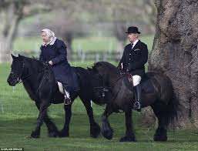
No Day light – no penalties

Less than one horses length – 5 penalties

More than one horses length – 10 penalties

